WEEK 6

Design a suitable grammar for evaluation of

arithmetic expression having + and – operators.

+ has least priority and it is left associative

- has higher priority and is right associative

**lex**

%{

#include "y.tab.h"

%}

%%

[0-9]+ {yylval=atoi(yytext); return NUM;}

[\t] ;

\n return 0;

. return yytext[0];

%%

int yywrap()

{

}

**yacc**

%{

#include<stdio.h>

%}

%token NUM

%left '+'

%right '-'

%%

expr:e {printf("Valid Expression\n"); printf ("Result: %d\n",$$); return 0;}

e:e'+'e {$$=$1+$3;}

| e'-'e {$$=$1-$3;}

| NUM {$$=$1;}

;

%%

int main()

{

printf("\n Enter an arithmetic expression\n");

yyparse();

return 0;

}

int yyerror()

{

printf("\nInvalid expression\n");

return 0;

}

OUTPUT

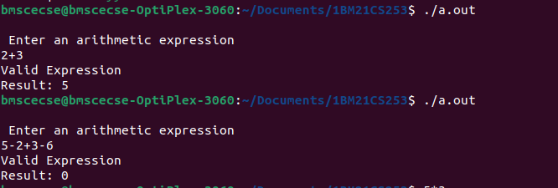

2.Design a suitable grammar for evaluation of arithmetic expression having + , – , * , / , %, ^ operators.

^ having highest priority and right associative

% having second highest priority and left associative

* , / have third highest priority and left associative

+ , - having least priority and left associative

%{

#include "y.tab.h"

%}

%%

[0-9]+ {yylval=atoi(yytext); return NUM;}

[\t] ;

\n return 0;

. return yytext[0];

%%

int yywrap()

{

}

%{

#include<stdio.h>

%}

%token NUM

%left '+' '-'

%left '*' '/' '%'

%right '^'

%%

expr: e { printf("Valid expression\n"); printf("Result: %d\n", $$); return 0; }

e: e '+' e {$$ = $1 + $3;}

| e '-' e {$$ = $1 - $3;}

| e '*' e {$$ = $1 * $3;}

| e '/' e {$$ = $1 / $3;}

| e '%' e {$$ = $1 % $3;}

| e '^' e {

int result = 1;

for (int i = 0; i < $3; i++) {

result *= $1;

}

$$ = result;

}

| NUM {$$ = $1;}

;

%%

int main()

{

printf("\nEnter an arithmetic expression:\n");

yyparse();

return 0;

}

int yyerror()

{

printf("\nInvalid expression\n");

return 0;

}

OUTPUT

